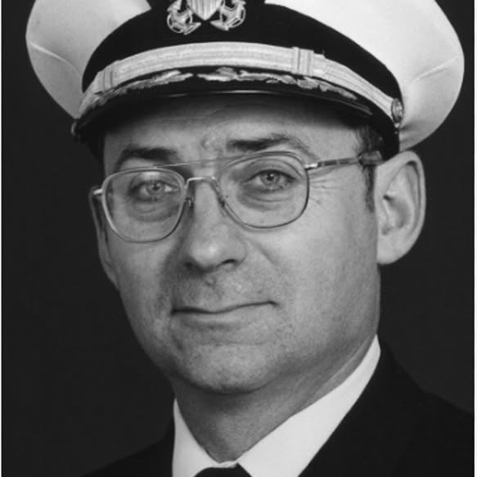

Captain Ira Eugene “Bud” Livingston, USN, 77, Salem, CT, beloved husband of Elaine Mary (Smeds), was called back to God Monday, June 6, 2016, after suffering complications from Alzheimer's Disease.
He was a Salem resident for the past 25 years.
Born on a farm in Farragut, Iowa in 1938, he was the son of Lora Edgar "Lew" & Daisy Dean (Lowry) Livingston. He graduated from Farragut High School in 1957.
In 1961, he graduated from the U.S. Naval Academy. Under Navy auspices, he earned Master's degrees from Harvard (International Relations) & the Naval War College (Strategic Studies). He completed more than 25 Cold-War patrols on seven U.S. nuclear (mainly ballistic-missile) submarines & one British fast-attack sub. He was Captain of the USS Nathanael Greene (SSBN 636). Ashore, he was: Director of Officer Training, Sub School, Groton; Ocean Policy Branch Head, Office of the Chief of Naval Operations, Pentagon; Faculty Member, Naval War College; & Chief of Staff, COMSUBEASTLANT, NATO Maritime Command, Northwood, UK.
Retiring from the Navy in 1991, he pursued a 20-year career with Sonalysts, Inc. in Waterford. He developed training for the NRC & DOE, including projects in Russia & Ukraine. He often consulted at Los Alamos Laboratories and at many nuclear-energy sites. Captain Livingston was a true American patriot. He loved talking with other submariners about their crucial role in winning the Cold War. For anyone unclear about the nature of the Soviet Union, he prescribed Solzhenitsyn's A Day in the Life of Ivan Denisovich.
He is survived by his wife of 55 years, Elaine; children, David Eugene of Petersham, MA, Elizabeth Mary of Newington, CT, and Nicole Marie (Curtis) & her husband Alan of Marietta, GA; sisters, Shirley Hall of Sidney, IA & his twin Darene Gutschenritter of Imogene, IA (he is predeceased by his brother Lora "L.E.", Jr.); four grandchildren, Phillip, Benjamin, Sophia & Cecelia; and Harmony Grace, a great-granddaughter.
A Mass of Christian Burial will be offered Saturday, 11 AM, at St. Matthias Church, East Lyme. He will be buried with full military honors at Arlington National Cemetery at a later date. Thomas L. Neilan & Sons East Lyme Funeral Home is in charge of arrangements. Memorials may be made to: Most Holy Trinity Monastery, Petersham, MA (maronitemonks.org); Fairview Nursing Home (fairviewct.org); or Alzheimer's Association (alz.org/ct). The family welcomes messages on his page at www.neilanfuneralhome.com.
NOTE #1: Ira Eugene “Bud” Livingston held the temporary rank of Rear Admiral when serving in command positions requiring that rank. Upon retirement from the Navy, he reverted to his permanent rank of Captain.

